
[Type here]

VOIP lab experiment#2 Configuring Elastix

Installation and Repair of Telecommunications Equipment

Name of student:
Group Number:
Date:

[Type here]
The purpose of the lab is to configure the Elastix software. You will be configuring the following settings:
- Type of installation
- Configure TCP/IP
- Time Zone
- Password
- IPV4 and IPV6
- Hostname configuration
- Time Zone selection

Type of installation

1- Choose Full install FreePbx 4.211.64 pressing enter
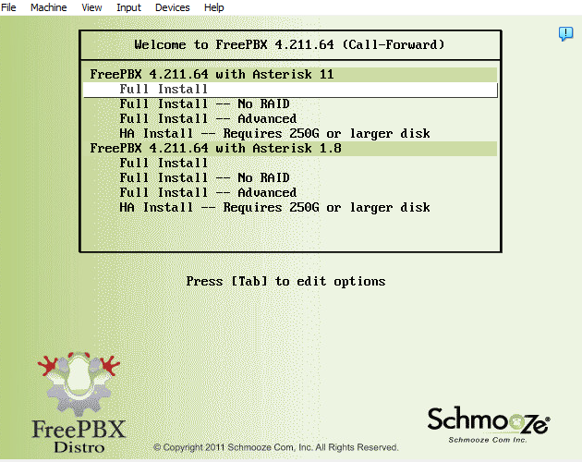

[Type here]

Configure TCP/IP
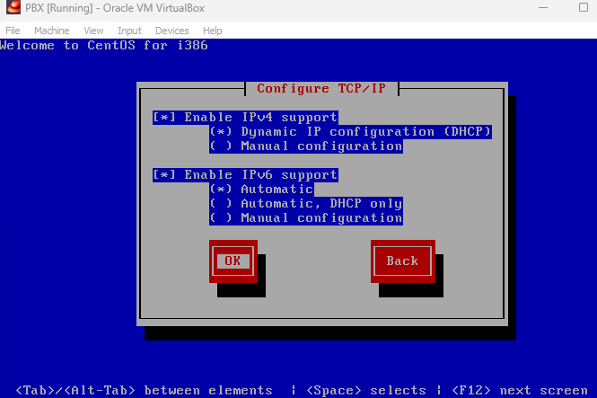

Press tab button to go to OK and then press “enter”
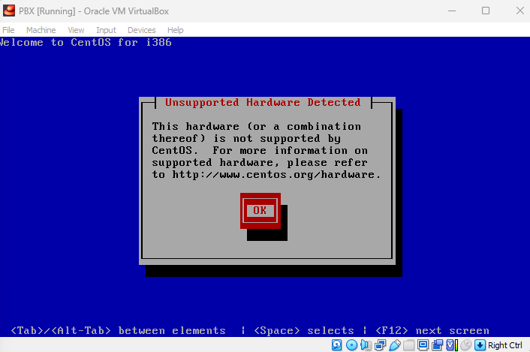
Just press “enter”

[Type here]

Time Zone

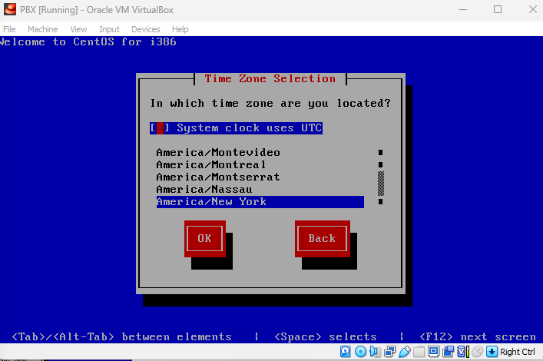

Press tab button to go to New york then select Montreal
Press tab button to go to OK and then press “enter”

[Type here]

Password selecting : use pec12345

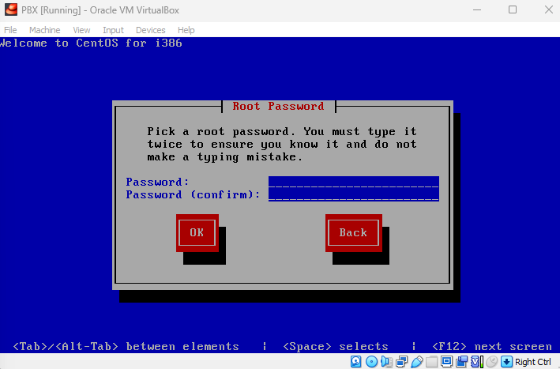
Press tab button to go to Ok and then press “enter”

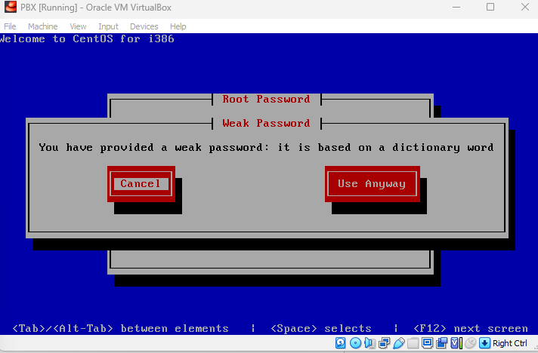
Press tab button to go to Use Anyway then press “enter”

[Type here]


[Type here]

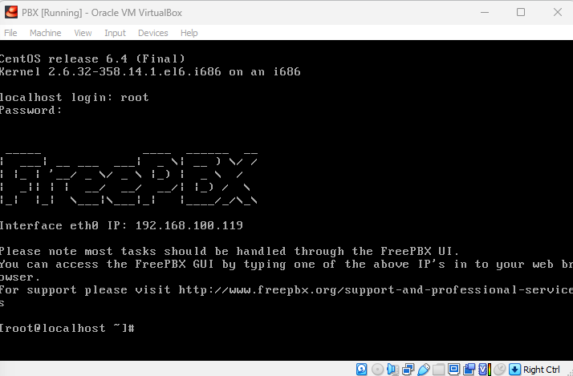

Username: root
Password: pec12345

Go to your google chrome and open the ip address showing in the screen.

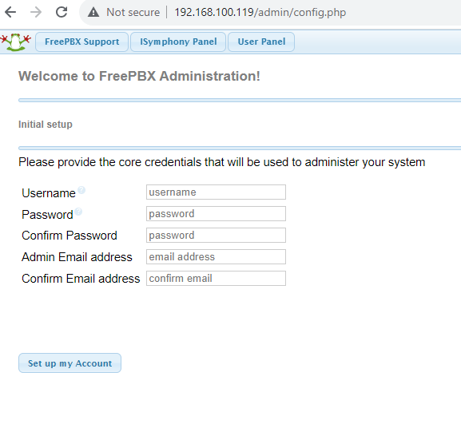
Create the admin user: Username: admin
Password: admin

